AP Studio Art: Drawing, 2D Art & Design, 3D Art & Design
Summer Assignments 2019-2020

Mrs. Heredia
KHeredia@mbusd.org
MCHSApArt.weebly.com

Dear 2019-2020 Class,

I look forward to working with you to develop your artistic vision. Please understand that you are enrolling in a class that will require a great deal of time, effort and motivation. The AP Studio Art course will be taught at a faster pace than the normal high school art course, with higher-level skills, outside projects, readings, gallery and exhibit visits expected. You will also work with your classmates to plan and execute art shows and are expected to participate in school art shows and department events throughout the year.

Expect to spend significant time outside of class working on your artwork in order to successfully prepare your A.P. Studio Art Portfolio. You will be creating a visual journal, and roughly a project every two weeks. You are also required to keep a digital portfolio. The grading is more stringent and the submission of a portfolio is mandatory. You will be responsible for photographing and documenting all work.
The test is changing next year! As an AP art student, you are asked to emphasize research, experimentation, exploration, discovery, inventive thinking, and problem solving. There are three portfolio options; Drawing, 2D Art & Design, and 3D Art & Design.
Consult these websites for information about the AP Studio Art program:
https://apcentral.collegeboard.org/courses : College Board website with course information
www.mchsApArt.weebly.com : Our class website and will have class information and assignments

During the coming year, you will build a portfolio of work to submit for the AP Exam. Summer assignments help to begin developing themes in your work and alleviate the pressure during the school year of producing the many quality pieces needed for a successful portfolio.
Please share this information with your parents/guardians.

All summer assignments are due at the beginning of class on the first day of school. If you do not have these assignments completed at that time, you will be transferred to a regular art class. No excuses will be accepted.

Summer Assignments

As an AP studio artist, you are expected to submit quality artwork that can be comparable to artwork produced at the college level. Your summer assignment requires a time commitment of at least 2-5 hours a week. They are vital to the development of your AP portfolio. In some cases, it will be a realization process for you to understand yourself better as an artist. Some of these pieces will be used in your final AP portfolio, make them your best!

#1 : THE BIG IDEA LIST
The majority of your AP portfolio consists of a sustained investigation. This is a very important element of the class. You will explore a theme, ask questions, do research and create both a visual journal and finished art pieces related to the topic you select.

Your assignment: LIST OF 60 POSSIBLE SUSTAINED INVESTIGATION TOPICS.
30 conceptual concepts: faith, chaos, freedom, anxiety, etc.
30 concrete ideas: flowers, the body, cars, etc.

You are not committed to any of these ideas yet, don’t be afraid to be silly or outlandish! You may combine concrete ideas and an abstract concept to form the basis of your sustained investigation. [List ideas here or in your sketchbook.]

 | CONCEPTUAL |  |  | CONCRETE
1 |  |  | 1
2 |  |  | 2
3 |  |  | 3
4 |  |  | 4
5 |  |  | 5
6 |  |  | 6
7 |  |  | 7
8 |  |  | 8
9 |  |  | 9
10 |  |  | 10
11 |  |  | 11
12 |  |  | 12
13 |  |  | 13
14 |  |  | 14
15 |  |  | 15
16 |  |  | 16
17 |  |  | 17
18 |  |  | 18
20 |  |  | 20
21 |  |  | 21
22 |  |  | 22
23 |  |  | 23
24 |  |  | 24
25 |  |  | 25
26 |  |  | 26
27 |  |  | 27
28 |  |  | 28
29 |  |  | 29
30 |  |  | 30

#2 : THE VISUAL JOURNAL _ Artist Research
Creating a visual journal will be an essential part of this course. You will need to obtain a sketchbook that you will use this summer and next year. This summer, you are developing a habit of working in your journal regularly. This is more than a sketchbook! Recommended: 9x12 inches (or similar size), heavy weight paper

Your assignment: FOUR TWO-PAGE SPREADS RESEARCHING ARTISTS
TWO artists of your choosing  1.  2. | TWO artists from this list:  Barbara Kruger (conceptual collage artist)  Kara Walker (contemporary, silhouettes)  Keith Haring (post-modern graffiti artist)  Jean-Michel Basquiat (post-modern graffiti)  Judy Chicago (contemporary feminist artist)  Georgia O’Keeffe (abstract painter) | Frida Kahlo (painter)  Yayoi Kusama (sculpture artist)  Alexander Calder (sculpture)  Alberto Giacometti (sculpture)  Jeff Koons (sculpture)  Maya Lin (architect)  Hannah Hoch (photomontage, Dada artist)

Your research pages should include the following:
- An applied background using chalk (be sure to spray fix), marker, watercolor, color pencils, graphite, etc.
- A picture of the artist
- A picture of your favorite work created by the artist
- Materials (The substances that the artist manipulates.)
- Process (The ways the artist plays with ideas and manipulates or applies materials. This might include placing time limits, harnessing chance, repeating motifs, collaborating, exploring materials, or using a new technique.)
- Context (The circumstances that surround the artwork. Where, when, how, and for what purpose the work was made), including what was historically and socially present for the artist at the time the artwork was made. Content (The concept, big idea, or subject of the artwork Note: The visible subject matter is not necessarily the same as the content. For example, water lilies were often Monet’s subject matter, but light was his content.)

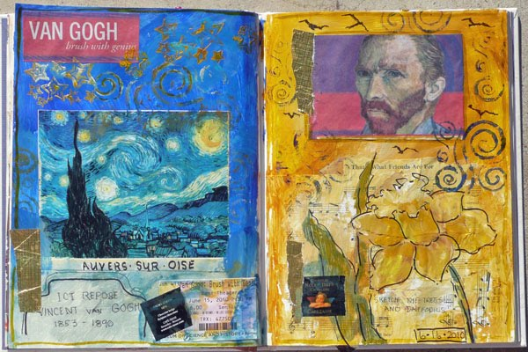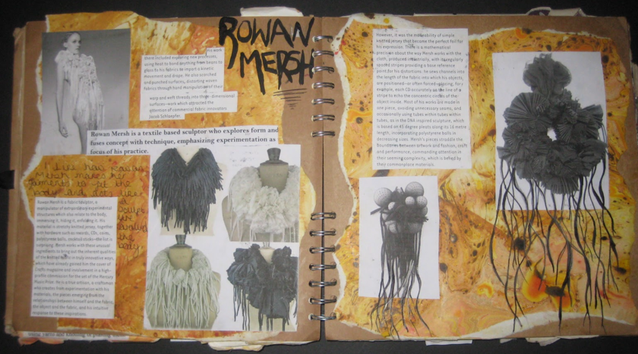

#3 : THE VISUAL JOURNAL _ Themes
The visual journal will be a place to explore concepts and experiment with materials.

Your assignment: SIX TWO-PAGE SPREADS EXPLORING THEMES AND MATERIALS
For each page, mix and match a different topic, design element and technique: (EX: Identity, Emphasis, Sewing)

TOPIC | Design Element | Technique
Life & Death | Balance | Sew pages using thread or embroidery floss
Social Issue (pick one) | Contrast | Collage and attach things
Innovation in Science | Emphasis | Use different texts/fonts
Identity | Movement | Create doors, pockets or flaps
Culture (pop, local, global) | Repetition | Transfer something (using acetone, clear shipping tape or gel medium)
Spirituality | Variety | Glue pages together and cut openings and windows to other pages
Order vs Chaos | Unity | Journal — write down ideas, thoughts, research findings …
The Media | Positive/Negative Space | Create textures
Metamorphosis | Pattern | Include your own photography (print and collage)
The Environment | Color – use a color scheme such as monochrome, complementary, triadic, etc. | 3D elements (fold out or pop up style pieces)

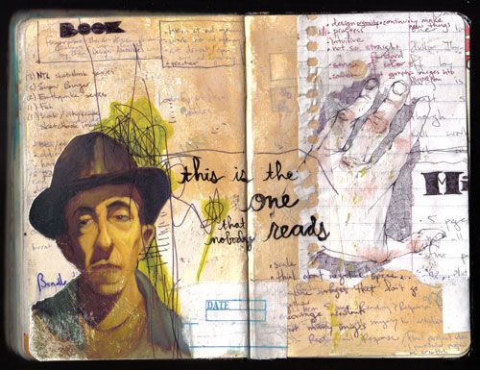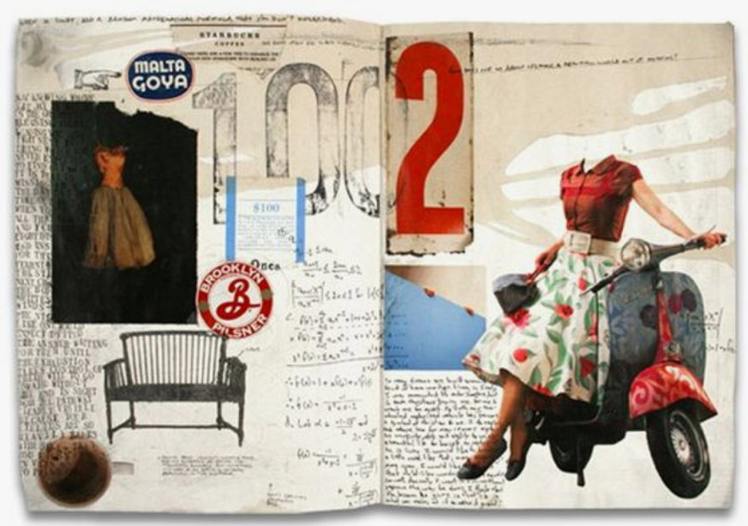
#4 : THE FINISHED ARTWORK

Your assignment: Create finished artwork based on pages in your visual journal. For each piece, select one of the visual journal pages and develop in your chosen medium (drawing, 2D Design or 3D Design). These works should reflect your BEST efforts and ability. You can also use this time to experiment with different media or artistic styles. Additional pieces are, of course, encouraged.

Drawing portfolio– Create THREE PIECES. Each piece should be 18x24 inches or smaller. If using canvas, work on flat panels (not stretched). Include some observational drawing.
2D Design portfolio - Create THREE PIECES. If you are working in Photography, you need to take at least 50 photos, if not more, for each project. Remember that moving slightly can totally change a photograph. Think about composition, your background, elements of art and principles of design, and your lighting. Create a google drive folder of photographs for each project and print your final selection (8x10 minimum).
3D Design portfolio - Create TWO PIECES. Explore methods of attaching objects (wire, glue, sewing, etc.) to gain a background in various methods of construction that you can use throughout the year. Make sure your work is 3D and can be viewed from all sides.

All portfolios -- BE ORIGINAL: If you submit work that makes use of photographs, published images, and/or other artists’ work, you MUST show SUBSTANTIAL and significant development beyond duplication. This may be demonstrated through manipulation of the formal qualities of design and/or concept of the original work. It is unethical, constitutes plagiarism, and often violates copyright law to simply copy an image (even in another medium) that was made by someone else. This is true of any and all images on the Internet!

There is no right and wrong way to complete these besides not thinking it through. We WILL be critiquing these within the first week of class so be prepared.

#5 : OPTIONAL ACTIVITIES
1. See Art – Visit museums, local art galleries, performances or poetry readings. If you are traveling, try to set aside time to check out the local art scene. Take your sketchbook with you, and render the work as well as your response to it. It is a good thing to jot down your thinking process in your sketchbook as well as draw in it.
2. Take a Class – There are many excellent choices in the area to expand your art skills. Local options include the Manhattan Beach Creative Arts Center, Otis College, The Art Center College of Design and the UCLA Summer Art Institute.
.

Summer Assignment Checklist
ASSIGNMENT | START DATE | DATE COMPLETED
1. Review AP websites, look at example portfolios
2. The Big Idea List

3. Visual Journal – Artist Research (FOUR spreads)

4. Visual Journal – Themes (SIX spreads)
5. Project 1
6. Project 2
7. Project 3 (*2D and Drawing only)
Pace yourself and budget your time wisely!

